Investigations of Changes in Protein Structure After Processing for Bioplastics

Kenneth Switala
May 03, 2010
Advisor: Dr. Karpovich

Introduction
The purpose of this study was to investigate polysaccharides and proteins using experimental and computational techniques. The intended application of this research was to discover physical and chemical explanations for the differences in properties of bioplastics that occur when processed under different conditions. In particular a hypothesis was to be tested whether or not an observed red shift in the fluorescence spectra of soy protein isolate was due to the increased favorability of aromatic stacking interactions, but this red shift in previous data was not reproduced at low concentrations of protein. The experimental techniques utilized were FTIR-ATR and fluorescence spectroscopy. No clear results were obtained for protein structural changes, but work remains to be done to fully explore the ability of these experimental techniques to produce information on protein chemistry.

Procedure/Experimental

Samples prepared
All pellets consisted of approximately 1.0g of soy protein isolate from the commercial source. Pellets were powdered using a mortar and pestle shortly after they were pressed.

- Commercially prepared soy protein isolate that was not modified
- SPI pressed at 10000psi
- SPI heated to 130C and pressed at 10000psi while still hot
- SPI heated to 130C, cooled, and left unpressed
- SPI heated to 130C, cooled, and then pressed at 10000psi
- Hydrated SPI, heated to 130C, and then cooled, dried and re-powdered
- Commercial soy meal that was powdered in a mortar and pestle
- Raw soy beans that were crushed and powdered and then defatted using hexanes

FTIR measurements
All measurements were performed using an ATR accessory and samples were in powdered form. The FTIR parameters used in the experiments were varied, but relevant experimental information is contained in the OPUS data files accompanying this report. All spectra were interpolated until they had a resolution of 0.5cm⁻¹. For comparison, spectra were scaled and matched to one another by minimizing their squared distance on an absorbance v wavenumber graph.

Fluorescence measurements
Powdered samples were dissolved in water inside a quartz cuvette that had a volume of approximately 4.5mL. Many of the relevant experimental parameters used for the measurements are included in the digital files for this report. Samples were measured at varying concentrations, from approximately 1 to 30 mg protein/mL water. Scans were taken at 480nm/min and the excitation wavelength used was 280nm and 295nm.

Software
The data processing and graphing was primarily done in the R statistical environment using custom routines. The code used is included with the digital files for this report. Also included is a handy OPUS FTIR data exporter written in Nemerle. All included code was written by the author of this report unless otherwise noted.

Hydrated soy protein preparation
A hydrated soybean sample was prepared to test the changes that occur when the protein denatures in water. A study by Kitabatake[1] suggested that thermal denaturation of a dry soy protein isolate would not occur at temperatures below 180C and as the water content is increased, the denaturation temperature is lowered. Rather than trying to denature the protein with higher temperatures, denaturing it in water was attempted.

- Mixed distilled water and 1.5g protein in a 2:1 ratio by weight. Kneaded water into protein in a mortar and pestle.
- Paste was placed in a glass bottle. An additional mL of water was added to the bottle and the bottle was shaken.
- Bottle was placed in a sand bath and heated at 130C in an oven for 2 hours.
- Protein 'gum' was removed from bottle and slowly dried on a surface of ~35C until it was dry enough to crush and separate into smaller pieces in a mortar and pestle.
- The drying and crushing process was repeated until a fine, dry powder was obtained.

Results
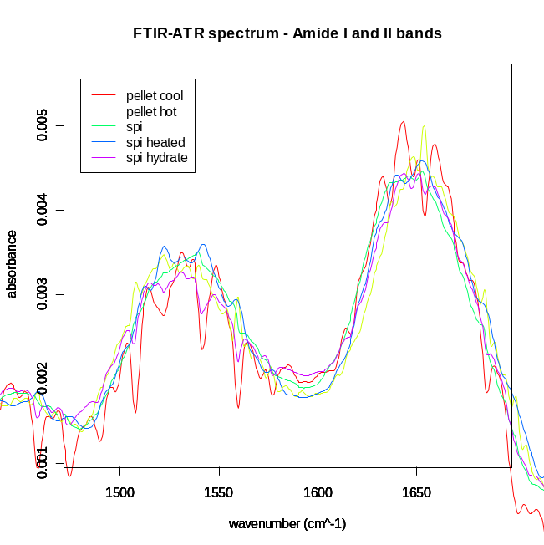Figure 1
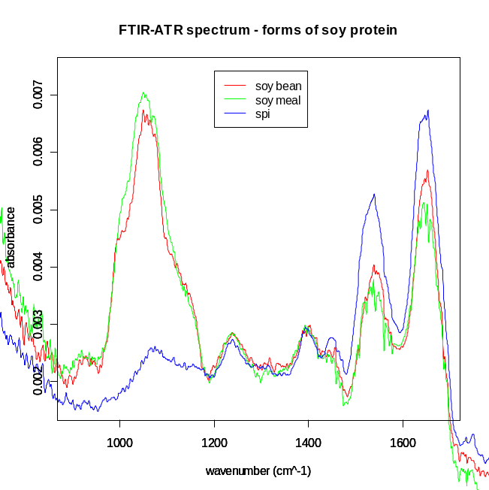Figure 2
Figure 1 shows the scaled and matched FTIR measurements for most of the samples prepared. There were no large differences between them, except for peaks due to water vapor over or under subtraction. Figure 2 compares the soy protein isolate with the soy meal and crushed soy beans that were defatted. The soy meal and raw soybean spectra appeared similar enough to say that they contain approximately the same extra compounds in addition to soy protein. Despite the water vapor issue, Fourier self deconvolution was performed on some of the data to see what would be obtained. Figures 3 and 4 show the results of the deconvolution routine implemented and applied to some simple Lorentzian test peaks, using Bessel smoothing with a cutoff of T = 0.8. This test was performed to verify that the routine was working correctly. The technique was implemented using descriptions of FSD from Griffiths[2] and Kauppinen[3]
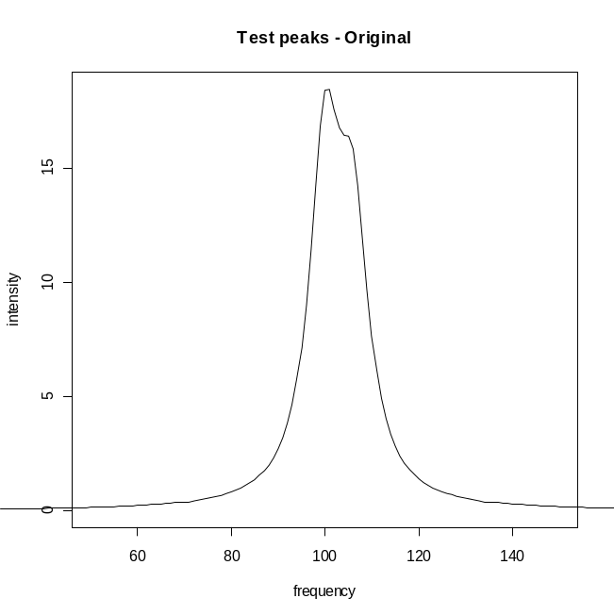Figure3
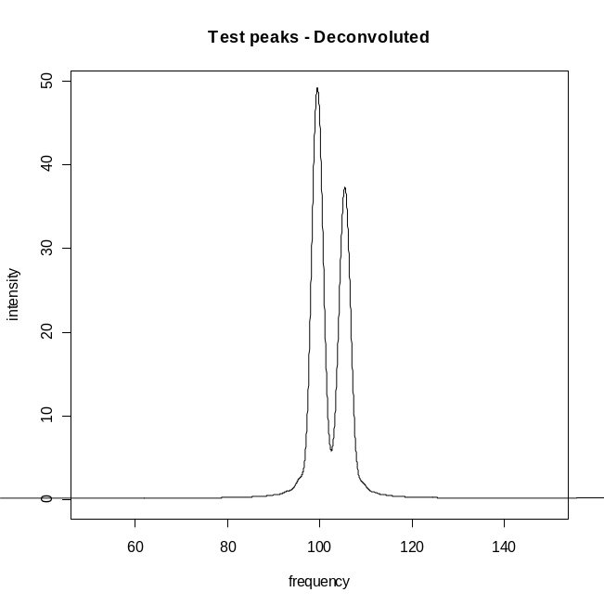Figure4
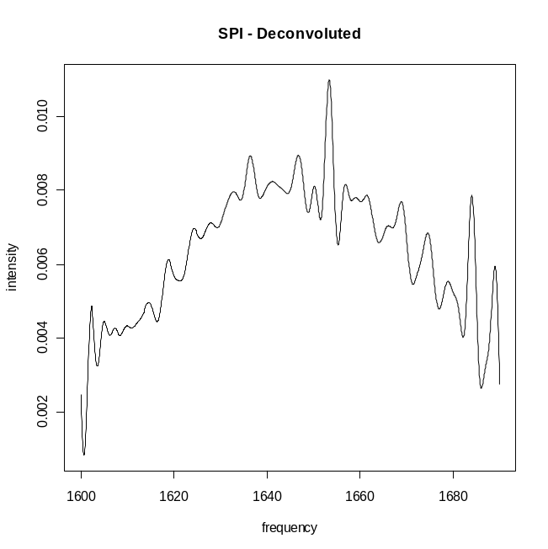Figure 5 - 4cm⁻¹ 256 scans
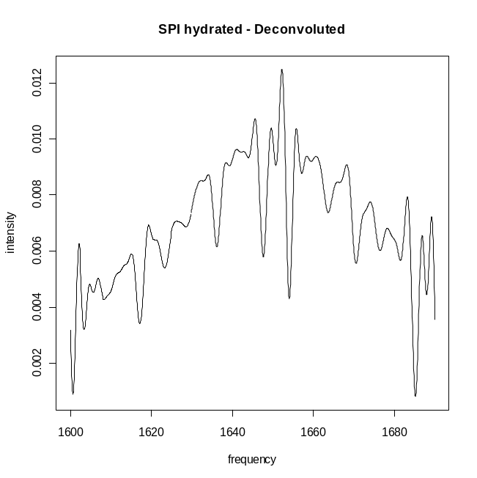Figure 6 - 4cm⁻¹ 1024 scans

Figures 5 and 6 show the result of deconvolution on SPI and SPI hydrate at 4cm⁻¹ resolution, Bessel smoothing using cutoffs of T = 4.5. These spectra were chosen for deconvolution because the water artifacts were minimal and there was a high number of scans taken. Most of the data was not of this quality so the routine could not be productively applied to the rest of it. Which peaks are artificial and due to water vapor was not sorted out, but the overall number and relative locations of of peaks in each figure appear to be preserved, with the SPI hydrate having sharper peaks due to the atmospheric water vapor. The absolute location of peaks may have shifted between the two figures, but it is difficult to tell visually. Removal of water vapor may be especially important because FSD assumes that the peaks have a certain shape, and over-subtraction of peaks may alter this shape and violate that assumption. Another issue is determining whether or not the spectra is over-deconvoluted, which could lead to spurious peaks.

Fluorescence
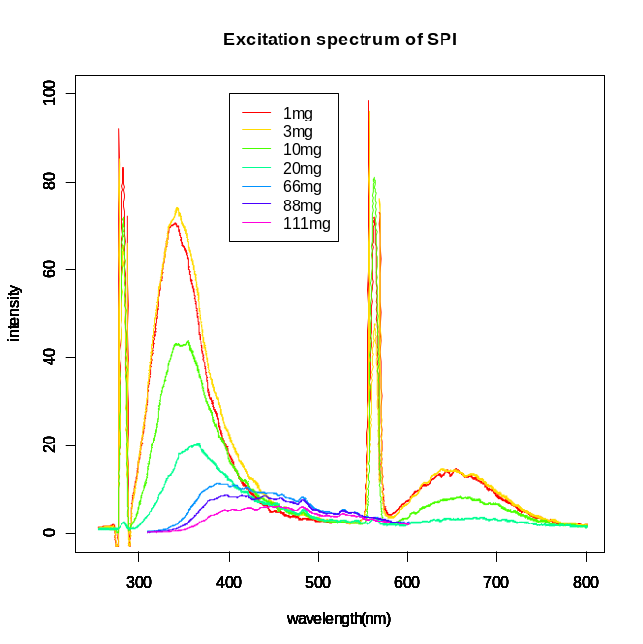Figure 7
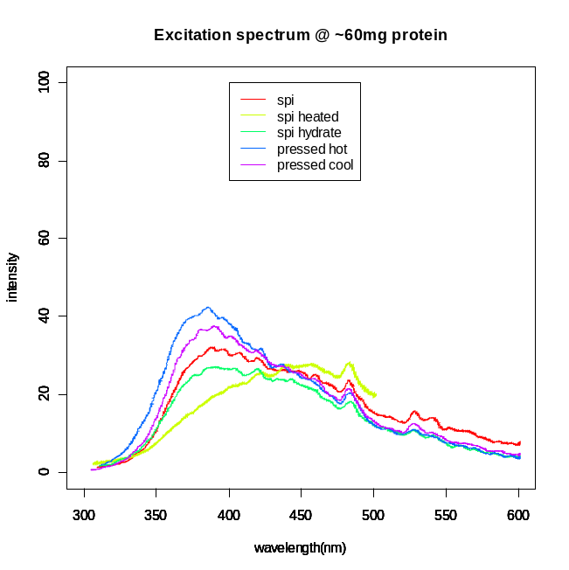Figure 8

The fluorescence spectra profiles depended on concentration and above 1mg/mL the spectra started to drastically shift as Figure 7 shows. This corresponds to about 4-5mg of dissolved protein inside the cuvette. At concentrations above 5mg/mL, the excitation lines and the peaks at 600nm-700nm disappeared. Figure 8 displays the spectra of various prepared samples taken at a fixed concentration. The intensity increase compared to Figure 7 is accounted for by the fact that Figure 7 data had a emission bandpass of 3nm and Figure 8 had one of 5nm. Also, in Figure 7 the 66, 88, and 111mg samples were taken at 5nm emission bandpass but scaled down by a factor of 5²/3² to account for the intensity change. There are clear differences in the profiles between samples, and the data indicates that certain samples require higher concentrations to achieve similar shifts in their fluorescence profiles.
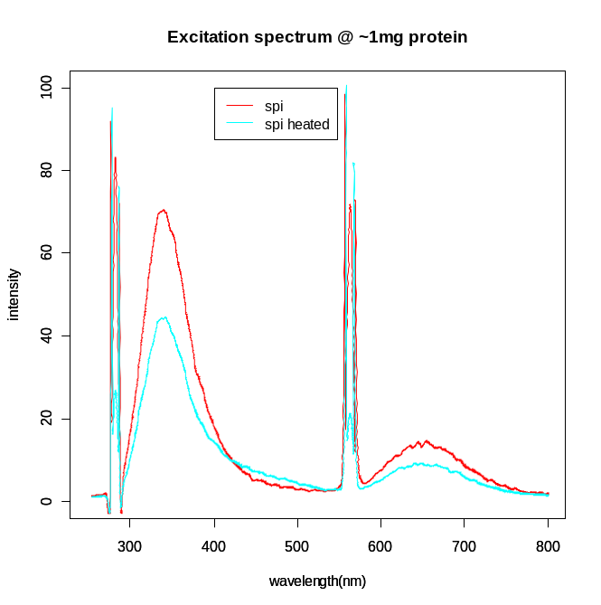Figure 9
Figure 9 is included to show that the maximum peak location appeared to be the same for the unmodified SPI vs the heated and unpressed SPI, but at the moment the change in intensity or profile is not analyzed because of the possible unreliability of actually measuring out 1mg of protein on the analytical balance into a partially wet quartz cuvette.

Discussion
FTIR
None of the samples showed clear shifts in the peak profiles at any of the major bands. This is reasonable given that the primary method of elucidating the secondary structure of proteins based on their FTIR spectra involves examining intensity changes in bands, and fixed band positions are to be expected in most common cases[4], assuming similar sample preparation and measurement technique[5]. It seemed worthwhile to investigate whether or not the secondary structures of the proteins could be measured because previous work actually correlated structure changes with the quality of protein films[6]. In the aforementioned study it was hypothesized that formation of beta sheets degraded film quality, and beta sheet formation was due to the denaturation of the protein.
Many of the samples taken at the beginning of this study had too much background and instrumental noise to reliably estimate their peak intensities. The most reproducible measurements were taken at 8 cm⁻¹ and 256 double-sided scans. At 4cm⁻¹, 1024 single sided scans (10 minute scan time) were required to begin to approach the reliability of the 8cm⁻¹ scans. The noise was most apparent in high wavenumber regions, and although this area is not usually analyzed quantitatively, it was an indicator of the overall noise level in the remaining regions. The amide I region commonly used for structural measurements is composed of approximately 25 bands in a region of 1624⁻¹ -1694 cm⁻¹. Most scans were taken at a resolution of 4cm⁻¹ because this appeared to be the minimum resolution quality used when secondary structure was being estimated, with some studies using instrumental resolutions as low as 0.5cm⁻¹.
A major problem that occurred at 4cm⁻¹ resolution was that atmospheric water vapor lines started to be resolved, and this greatly increased their maximum intensities. The reliability of background scans to remove these water artifacts was highly variable and generally unrepeatable when good subtraction did occur. The low intensity of the protein signal from the ATR accessory caused these bands to be fairly large in intensity relative to the protein bands. Fortunately, subtracting these lines is becoming a commonly automated procedure that once had to be done 'by hand', using custom procedures. Atmospheric subtraction was not applied to the data in this case.
Had the water vapor line been successfully removed using software or change in experimental conditions, the next step in quantifying secondary structure is resolution enhancement of the bands using Fourier Self Deconvolution. There are other techniques that can be used, but FSD was investigated for its simplicity and that it did not require advanced statistical techniques. The preliminary application of this technique seemed successful, but to gain more confidence with the technique, it should be applied to proteins of known secondary structure first and the accuracy of prediction gauged.
After the bands are deconvoluted and the shapes near the top of the peaks revealed, they would be in a suitable state to apply a curve fitting procedure. Since FSD preserves the relative areas and absolute frequencies of peaks[3], the fitted curves still correspond quantitatively to the secondary structure. No tools were located to perform this final step, but it seems commonly applied enough in other contexts so it is likely that free and easy to use tools to exist. There are also many literature sources describing different approaches and novel techniques that could be used[7]. However, until the water vapor subtraction and instrumental noise issues could be resolved it did not seem worthwhile to attempt to curve fit the data.
Finally, since part of this research was intended to be computational in character, some literature sources were sought that used theoretical models to explain and predict the FTIR spectra of proteins. Brauner et al[8] developed a method to predict the Amide I contour given X-ray crystal data of a protein, and concluded that computational models may be more suited towards allowing experimental FTIR data to assess changes in tertiary structure rather than secondary structure. They also stated that FTIR data may not be suitable for analyzing finer changes in secondary structure, despite previous assignments of fine structure to the many bands of the Amide I region.

Fluorescence
Less can be said of the fluorescence spectra, since the physical effects causing the shifts at high concentrations were not investigated. The heated and unpressed SPI showed the greatest shift and almost twice as much unmodified SPI is required to achieve the same overall profile. It is also interesting that the hydrated SPI appeared to prevent the spectral effects that heating had on the dry SPI. There may be information contained in these observations, but a better survey of the basic techniques already performed on proteins needs to be completed, and this information may be better quantified by alternative techniques than spectroscopy.
For computational approaches, a few studies that involved predicting fluorescence and decomposing spectra were discovered, but less time was spent studying them in detail. Unlike the approach taken by Brauner et al for the Amide I region of proteins for FTIR, computational analysis of the fluorescence spectra of large proteins may not be easily accomplished[9]. Reshetnyak et al[10] decomposed the spectra of proteins and correlated spectra profiles to the microenvironment of tryptophan residues, but the large number of unique environments that exist in SPI may be too complicated to use this approach. Lathey[11] details a method using Hyperchem to predict fluorescence of molecules, but modifications would be needed to make these computations feasible for large proteins.

Polysaccharides
The incorporation of polysaccharide modeling into this work was not accomplished despite the intent to. A software tool called Shape was found for setting up the sugar conformations in a computational polysaccharide dynamics simulation, but it would not be usable without the MM3 force field software or some other modifications to the source of the tool itself. Also, if only cellulose sugars are to be investigated in the future then there may already be data for the conformations of this common structure.

Conclusions
Approaches to protein structure that utilize both experimental results and theoretical calculations are very attractive for many reasons, but the existing ones do not appear to be in a state sufficient for routine analysis of proteins with atypical properties. Adding interactions with sugars into the mix may also go far beyond their current applicability. One piece of advice that was mentioned frequently in studies utilizing these experimental techniques was that they are merely complementary to arrays of other investigations that must be performed to get a clear picture of what is going on, such as the use of circular dichroism on proteins to discover secondary structure.
Bioplastics are certainly a unique application of protein chemisty, so novel or nonstandard approaches to experimental protein structure may be needed besides the usual ones to discover the reasons for the differences in plastic strength, if these differences are related to the protein structure in any way. One avenue that was not investigated in this study was a pure computational approach. The dynamics could be simulated when experimental setups to measure this are not feasible, such as the states of proteins during pressing or heating, and when processed with polysaccarides. Results taken from computational simulations may offer novel ideas and lead to development of unique experimental tests to verify the correctness of the simulations.
For future work in making the current approaches taken in this study successful, a routine for atmospheric vapor subtraction must be implemented, located or purchased to continue with the FTIR experiments. For fluorescence, if any quality data is to be taken it must carefully control for concentration and either volumetric flasks and hours of stirring will certainly be necessary to achieve concentrations that have stable fluorescence spectra. Both types of analysis should be applied to standard, more easily predictable proteins before attempted on SPI. SPI is also known to consist of many differing proteins, so fractionating the proteins in some way and analyzing the separated samples could provide new information that could be combined to make predictions about the entire sample. Differential scanning calorimetry appears to be a popular approach to determining whether or not a protein has been denatured or not, and applying it to the samples may offer useful information.

